SET-7 — Customer Demographics Analysis
AIM
To analyze customer demographic data and visualize the distribution of customer ages, gender, and demographic information using R programming.
ALGORITHM
- Start RStudio.
- Create the Customer Demographics dataset.
- Create a bar chart to visualize customer ages.
- Create a pie chart to represent customer gender distribution.
- Display the demographic information in a table.
- Add suitable titles and axis labels.
- Display the output.
- Stop.
R CODE
customer<-data.frame(Customer_ID=c(1,2,3),Age=c(28,35,42),Gender=c("Female","Male","Female"),Income=c(50000,60000,75000))
barplot(customer$Age,names.arg=customer$Customer_ID,main="Distribution of Customer Ages",xlab="Customer ID",ylab="Age")
gender<-table(customer$Gender)
pie(gender,main="Distribution of Customers by Gender")
customer
OUTPUT
- 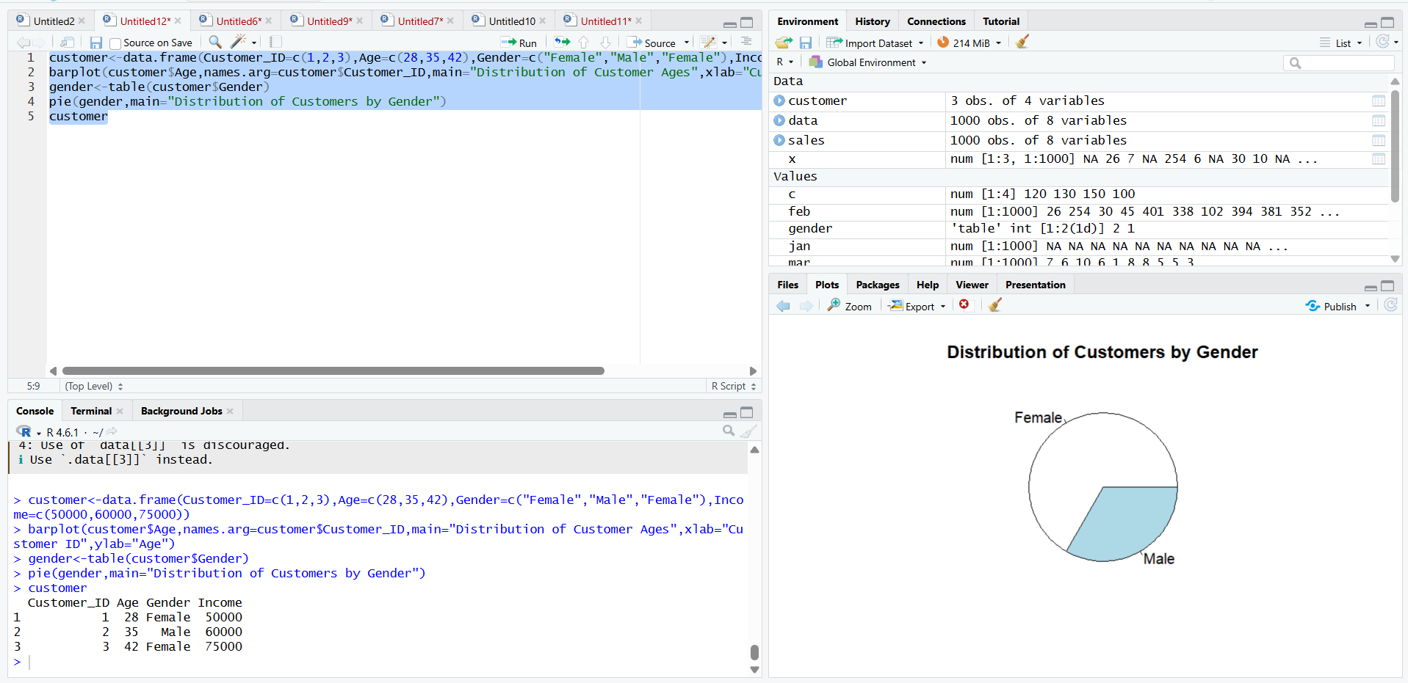Distribution of Customer Ages bar chart
- Distribution of Customers by Gender pie chart
- Customer Demographics table
RESULT
Thus, the Customer Demographics data was successfully analyzed using R programming. The bar chart, pie chart, and demographic table were successfully created.

